Project Report Format

# INTRODUCTION

* 1. Project Overview:

Smart Sorting is an AI-powered solution that leverages transfer learning to detect whether fruits and vegetables are healthy or rotten. A user-friendly web application allows image uploads and provides predictions with confidence scores and recommendations such as “Good to Eat” or “Don’t Eat.”

* 1. Purpose:

The primary goal is to minimize food waste and enhance consumer decision-making by enabling real-time quality detection of fruits and vegetables using image classification.

# IDEATION PHASE

* 1. Problem Statement
  2. Empathy Map Canvas
  3. Brainstorming

# REQUIREMENT ANALYSIS

* 1. Customer Journey map
  2. Solution Requirement
  3. Data Flow Diagram
  4. Technology Stack

# PROJECT DESIGN

* 1. Problem Solution Fit
  2. Proposed Solution
  3. Solution Architecture

# PROJECT PLANNING & SCHEDULING

* 1. Project Planning

# FUNCTIONAL AND PERFORMANCE TESTING

* 1. Performance Testing

# RESULTS

* 1. Output Screenshots

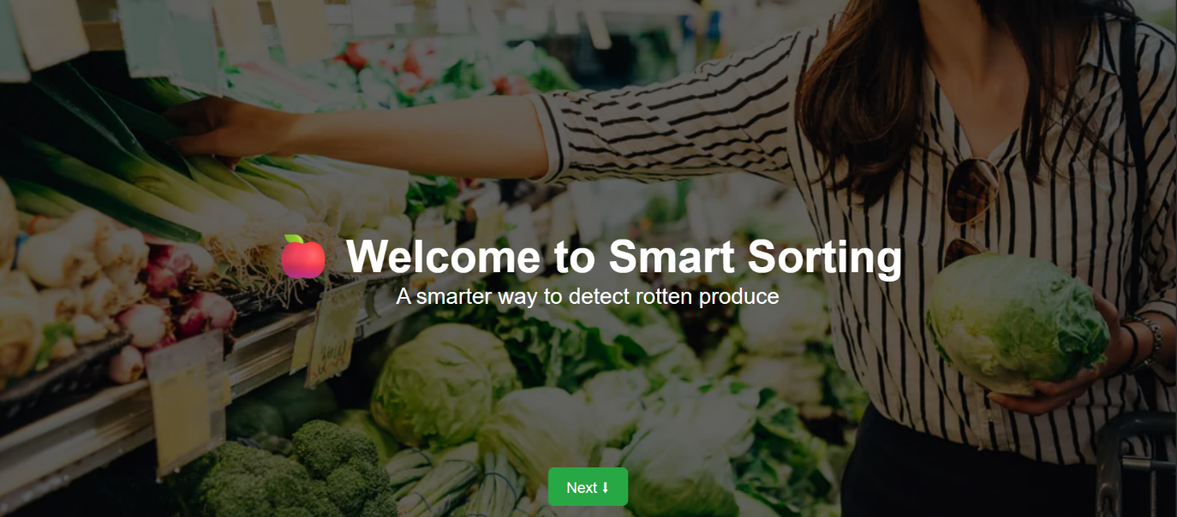

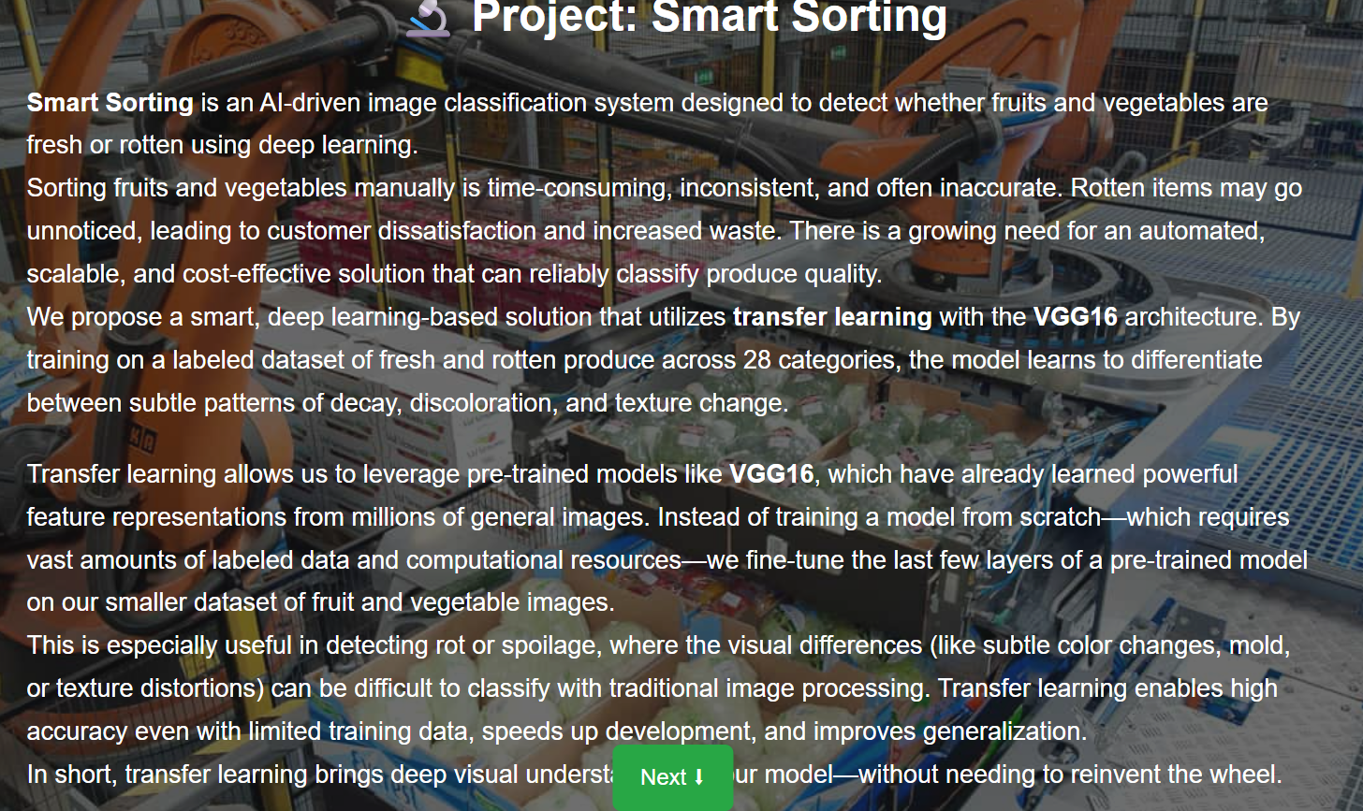

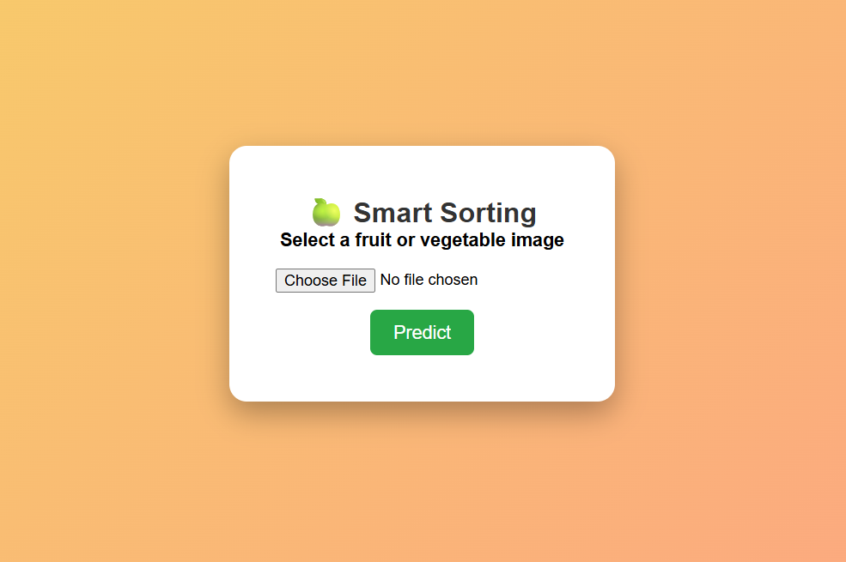

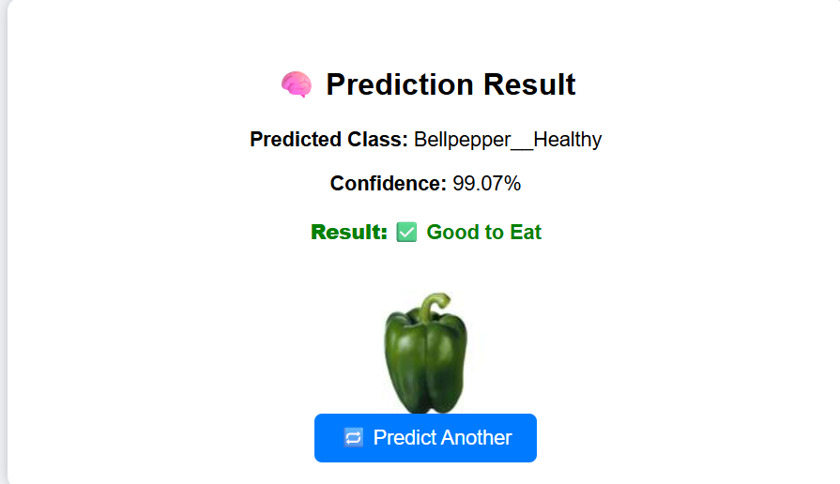

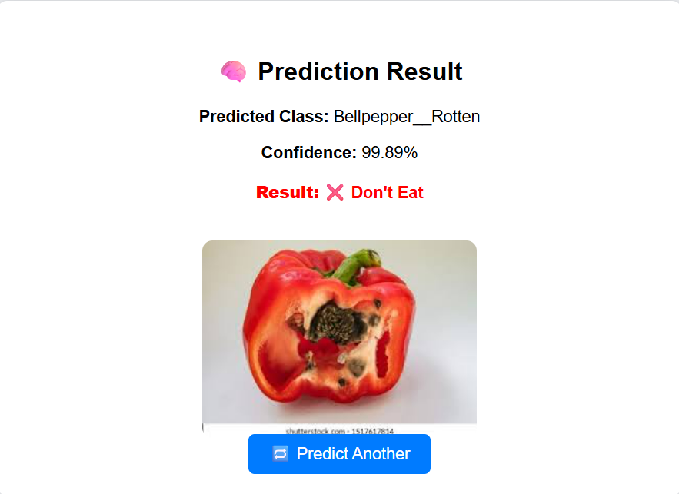

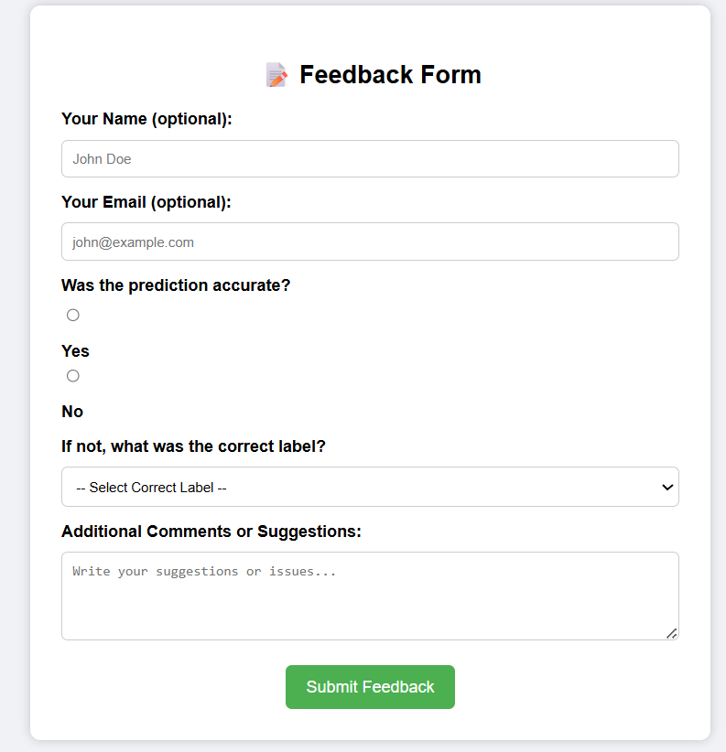

1. **ADVANTAGES & DISADVANTAGES**

|  |  |
| --- | --- |
| **Advantages** | **Disadvantages** |
| **Reduces food waste** | **Limited to image quality** |
| **Enhances decision-making** | **Depends on dataset diversity** |
| **Easy to use for all audiences** | **Needs stable internet for predictions** |
| **Fast and accurate predictions** | **Not a replacement for expert inspection in critical use cases** |
| **Portable web-based solution** | **Not a complete replacement for experts** |

1. **CONCLUSION**

Smart Sorting successfully demonstrates the use of deep learning (transfer learning with VGG16) to classify produce images into healthy or rotten categories. The integrated web application offers an intuitive user experience, promotes food safety, and empowers users with reliable decisions backed by AI predictions. This project can be further enhanced with more diverse datasets, mobile app support, and integration with supply chain tools for large-scale adoption

1. **FUTURE SCOPE**

* Add **user login** with JWT authentication
* Store **prediction history** in a database
* Convert backend from Flask to **FastAPI** for performance
* Add **mobile support/PWA version**
* Improve dataset with real-world captured images
* Enable **bulk image classification**

1. **APPENDIX**
   1. Dataset Link

[**https://www.kaggle.com/datasets/muhammad0subhan/fruit-and-vegetable-disease-healthy-vs-rotten**](https://www.kaggle.com/datasets/muhammad0subhan/fruit-and-vegetable-disease-healthy-vs-rotten)

* 1. GitHub & Project Demo Link
     + GitHub Link

<https://github.com/MMBhaveshHRK/Smart-Sorting>

* + - Project Demo Link

<https://drive.google.com/file/d/1quqM_IQEYPyNyhenzheFxCVefvk2eQg1/view?usp=drive_link>